## X Path(Two Types)

1. Absolute x-path
2. Relative x-path

Relative Path:

X- Path with attributes:

ID,Name,Title,Class,Alt(unique attribute)

Syntax: .// or //

.//tagname [@attribute=’attribute value’]

.//input[@id=’ sb_form_q’]

//..document

X path with texts

.//tagname[text()=’textvalue’

.//span[text()=’Languages:’]

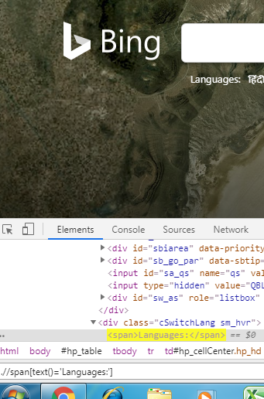

X Path with Contains

Synatax:

.//tagname[contains(@attribute,’partial attribute value’)]

.//input[contains(@id,’sb_form_’]

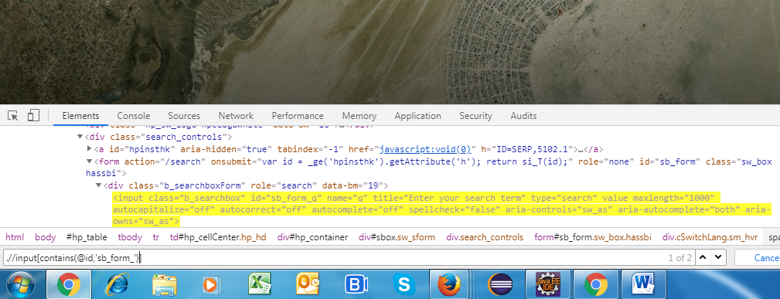

X Path with Starts with

Synatax:

.//tagname[contains(@attribute,’partial attribute value’)]

.//input[starts-with(@id,’sb_form_’)]

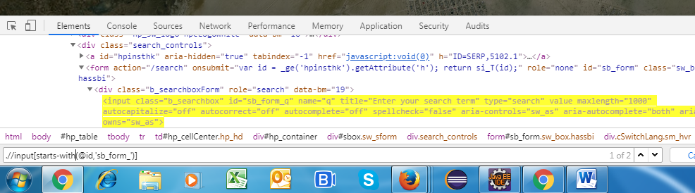

X Path with Ends with

Synatax:

.//tagname[contains(@attribute,’partial attribute value’)]

.//input[starts-with(@id,’sb_form_’)]

X Path with Following Elements:

Syntax:

.//tagname[text()=’textvalue’]/foll

.//span[text()='Languages:']/following::a[5]

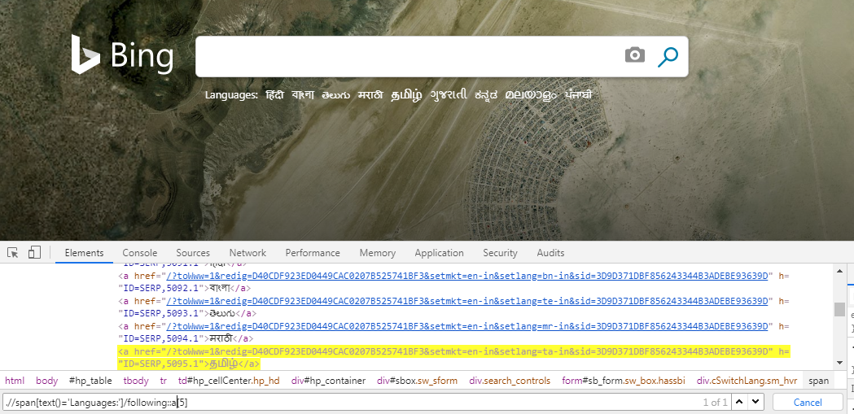

X Path with preceding elements

.//a[text()=’News’]/preceding::a[1]

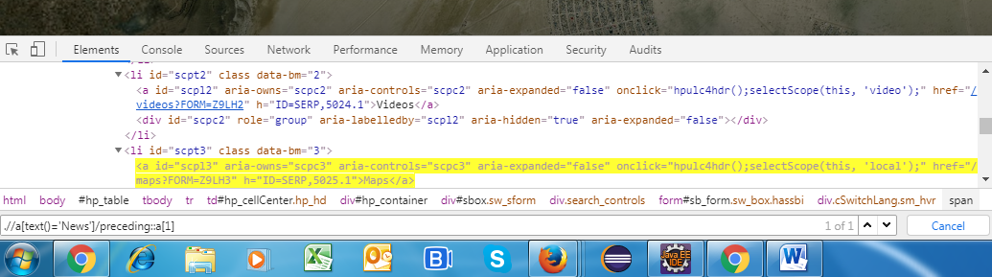

AND Operator:(&)

.//input[@id=’sb_from_q’]

Or

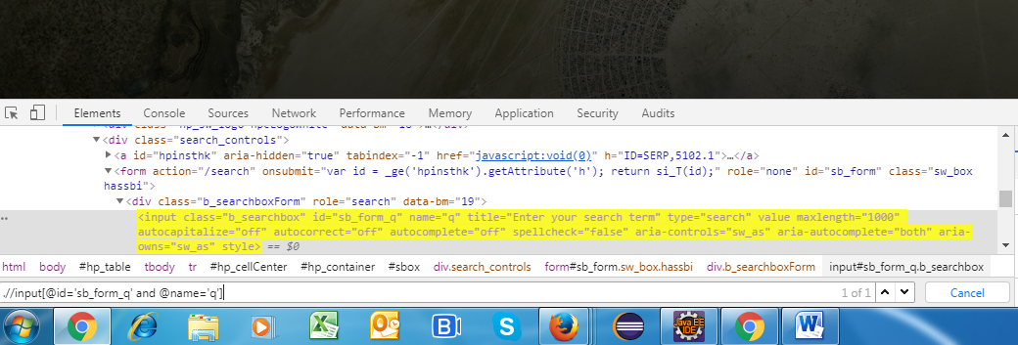

or

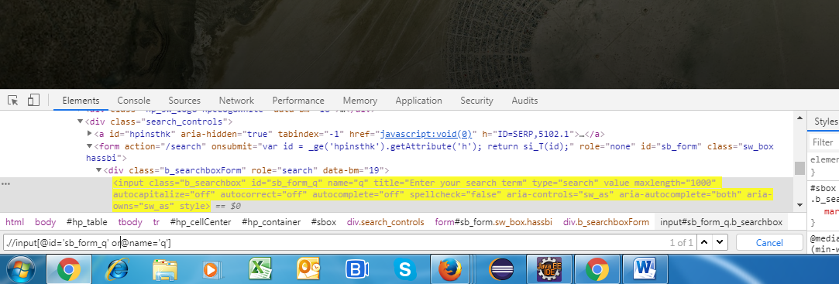

**CSS Selector:**

**Id = #**

**Class= .**

**Id**

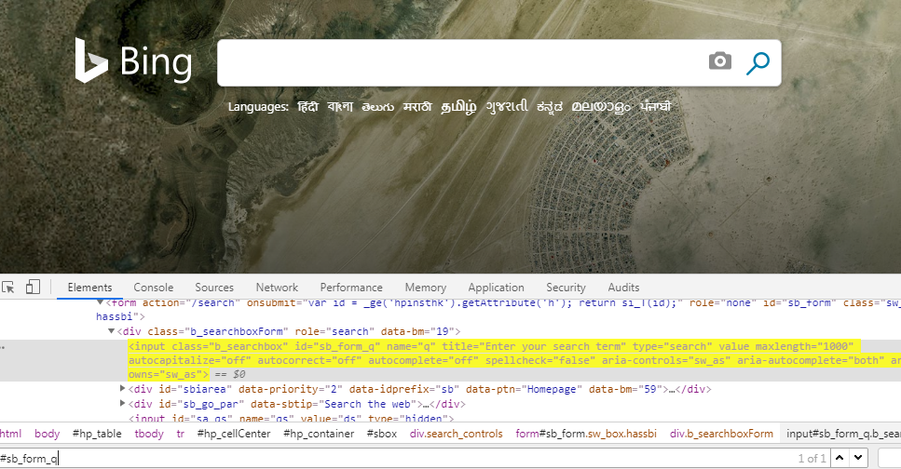

**Class:**

**.b_searchbox**

**CSS with tag:**

**Tagname[attribute=’attribute value’]**

**Input[id=’sb_form_q‘]**

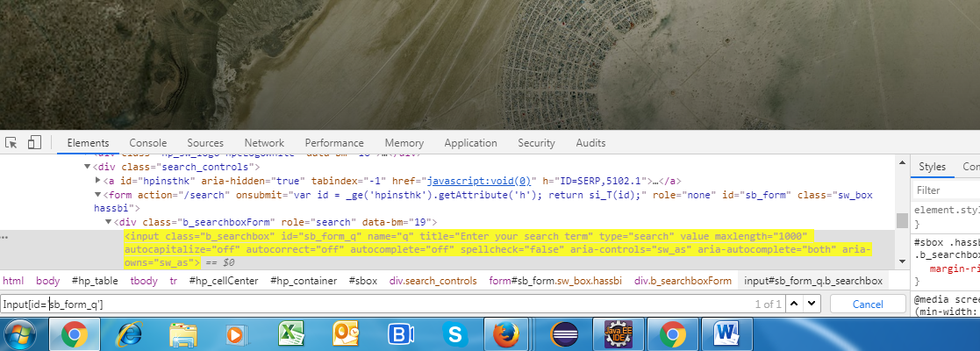

**CSS with contains**

**Input[id*=’sb_form_q‘]**

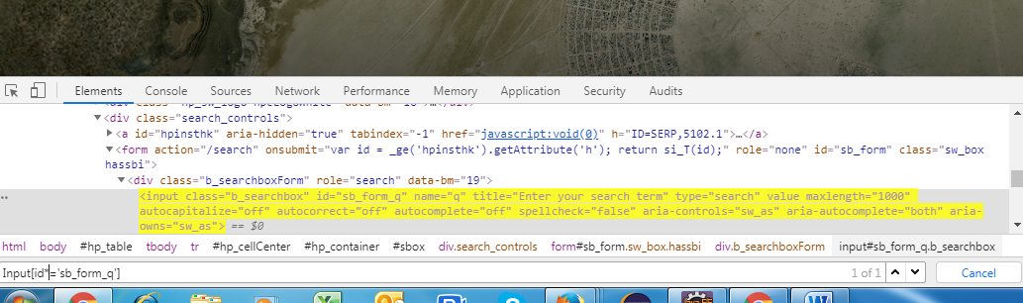

**CSS with Starts with**

**Input[id^=’sb_form_q‘]**

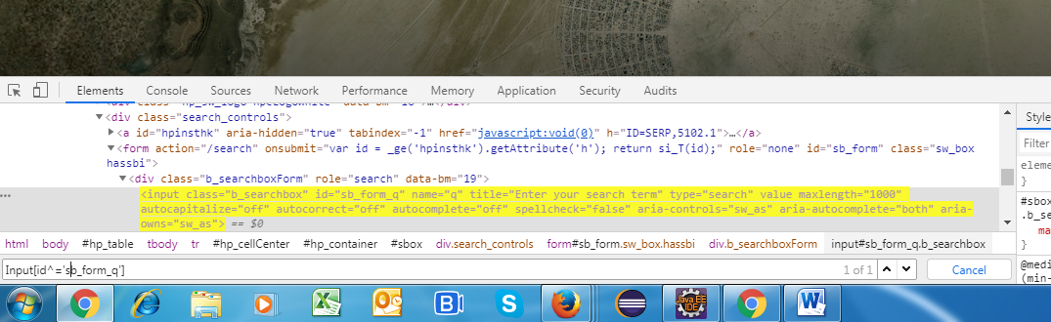

**CSS with Ends with**

**Input[id$=’sb_form_q‘]**

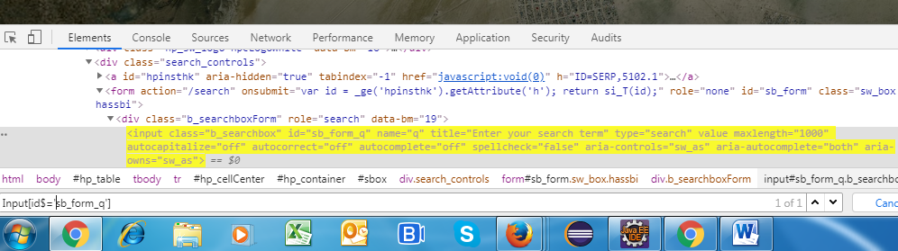

**CSS with selector with OR operator**

**Input[id=’sb_form_q’][name=’q’]**

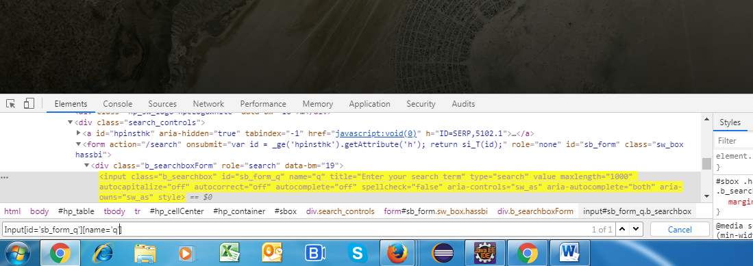

**CSS with selector with OR operator**

**Input[id='sb_form_q'],[name='a']**

